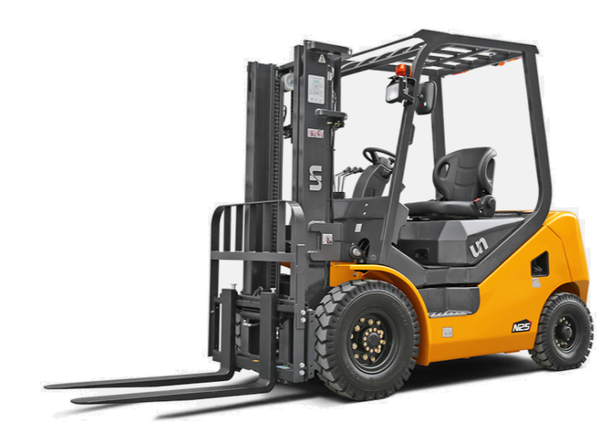
UN FDG25
Lifting capacity : 2.5T
Flexible solid tires
Triplex 4.7 meter mast
Forks 1.150mm
Integrated side shift (lateral movement of the forks)
Work lights
High beam headlights
Charger
Comfort seat
Roof
Mirrors

