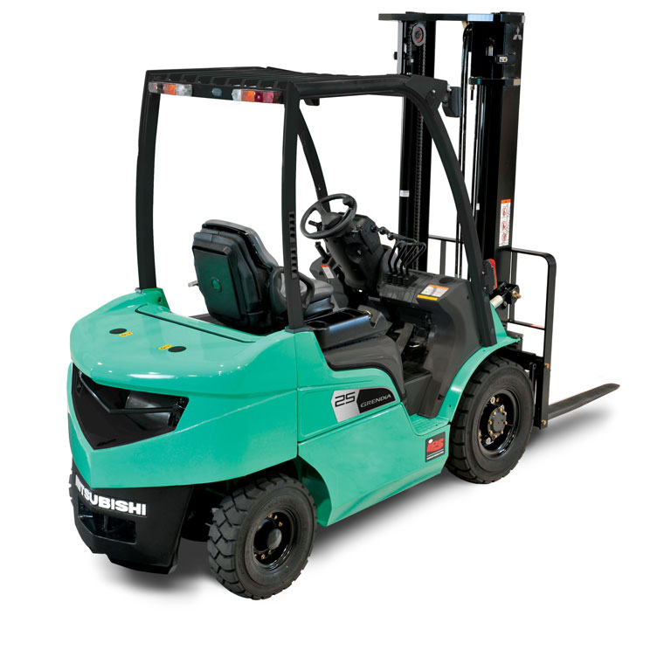
MITSUBISHI
Type: FB25N-80E
Arm rest direction : Yes
Armrest for luxe : Yes
Auto light switch: : Yes
Load backrest: : YES
Blind spot mirror: : YES
Floor light: : Yes
Plexiglass roof: : Yes
Int sideshift : 920 MM
Load indicator: : Yes
Pair of forks 1150 : YES
Pin code access: : YES
Road light kit: : Yes
Rear vieuw mirror: : Yes
Delux seat: : Yes
Reverse warning: : Yes
Stroboscope: : Yes
Tilt centering: : Yes
Second function tilt: : Yes
Full tires: : Yes
Wide rear view : Yes
Tiltcylinder 1.5 fwd / : YES
Triplex mast: : 4800 mm
4-way fingertip valve: Yes
4-way triplex mast : Yes

